**Business problem**

In recent years, city hotel and resort hotel have seen high cancellation rate. Each hotel now dealing a number of issues as a result including fewer revenues and less than ideal hotel room use. Consequently, lowering cancellation rate is both hotels’ primary goal in order to increase their efficiency in generating revenue and for us to offer through business advice to address the problem.

The analysis of hotel booking cancellation and other factors that have no bearing on their business and yearly revenue generation are the main topic of this report.

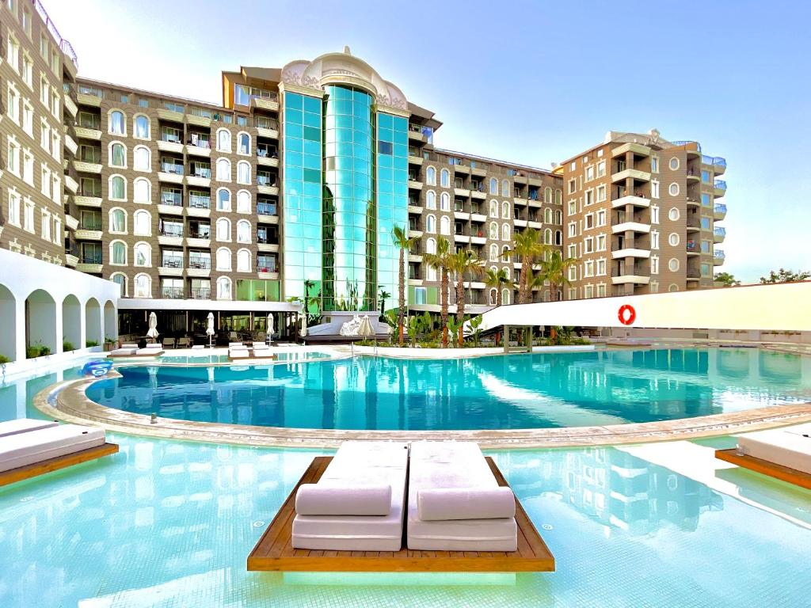

**RESEARCH QUESTIONS**

* What are the variables that affect hotel reservation cancellation?
* How can make hotel reservation cancellation better?
* How will be hotels assisted in making pricing and promotional decision?

**HYPOTHESIS**

* More cancellation occur prices are higher
* When there is longer waiting list customer tends to cancel frequently
* Majority of clients come from offline travel agencies

**ANALYSIS AND FINDINGS**

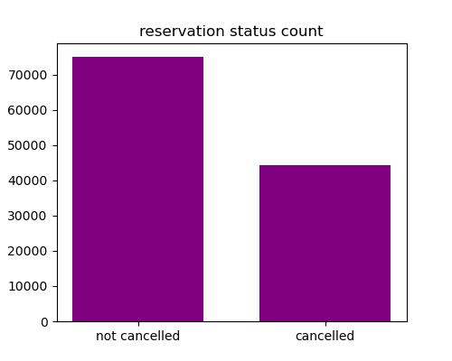

The accompanying bar graph shows the percentage that are cancelled and that are not. It is obvious that there are significant numbers of hotels that have not been cancelled. There are still 37% of clients who cancelled which make an impact on hotel’s earnings.

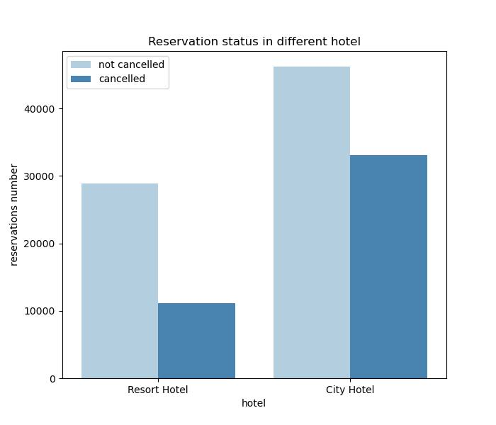

In comparison to resort hotels city hotels have more booking it is possible resort hotel is more expensive than city hotels.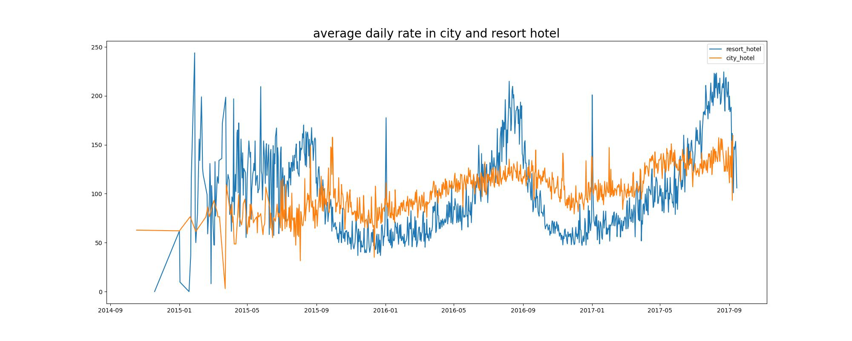

The line graph shows on a certain days the average daily rate of city hotels is less than that of resort hotels and on the other days it is even less. It goes without saying weekends and holidays may see the rise in resort hotel rates.

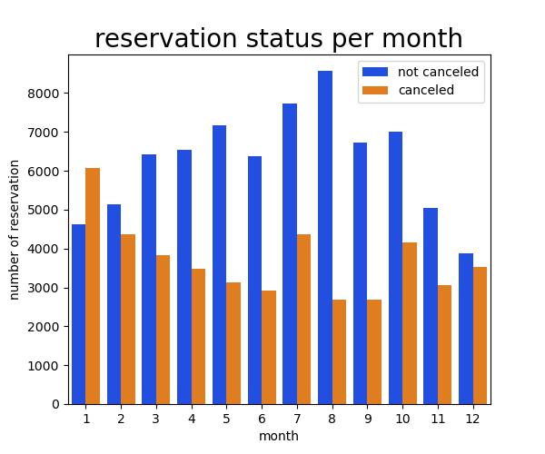

We have developed grouped bar graph to analyse the months with the highest and lowest reservation levels according to reservation status. As can be seen that the largest number of confirmed reservation in the month of august and January is the month of the most of the cancelled reservation.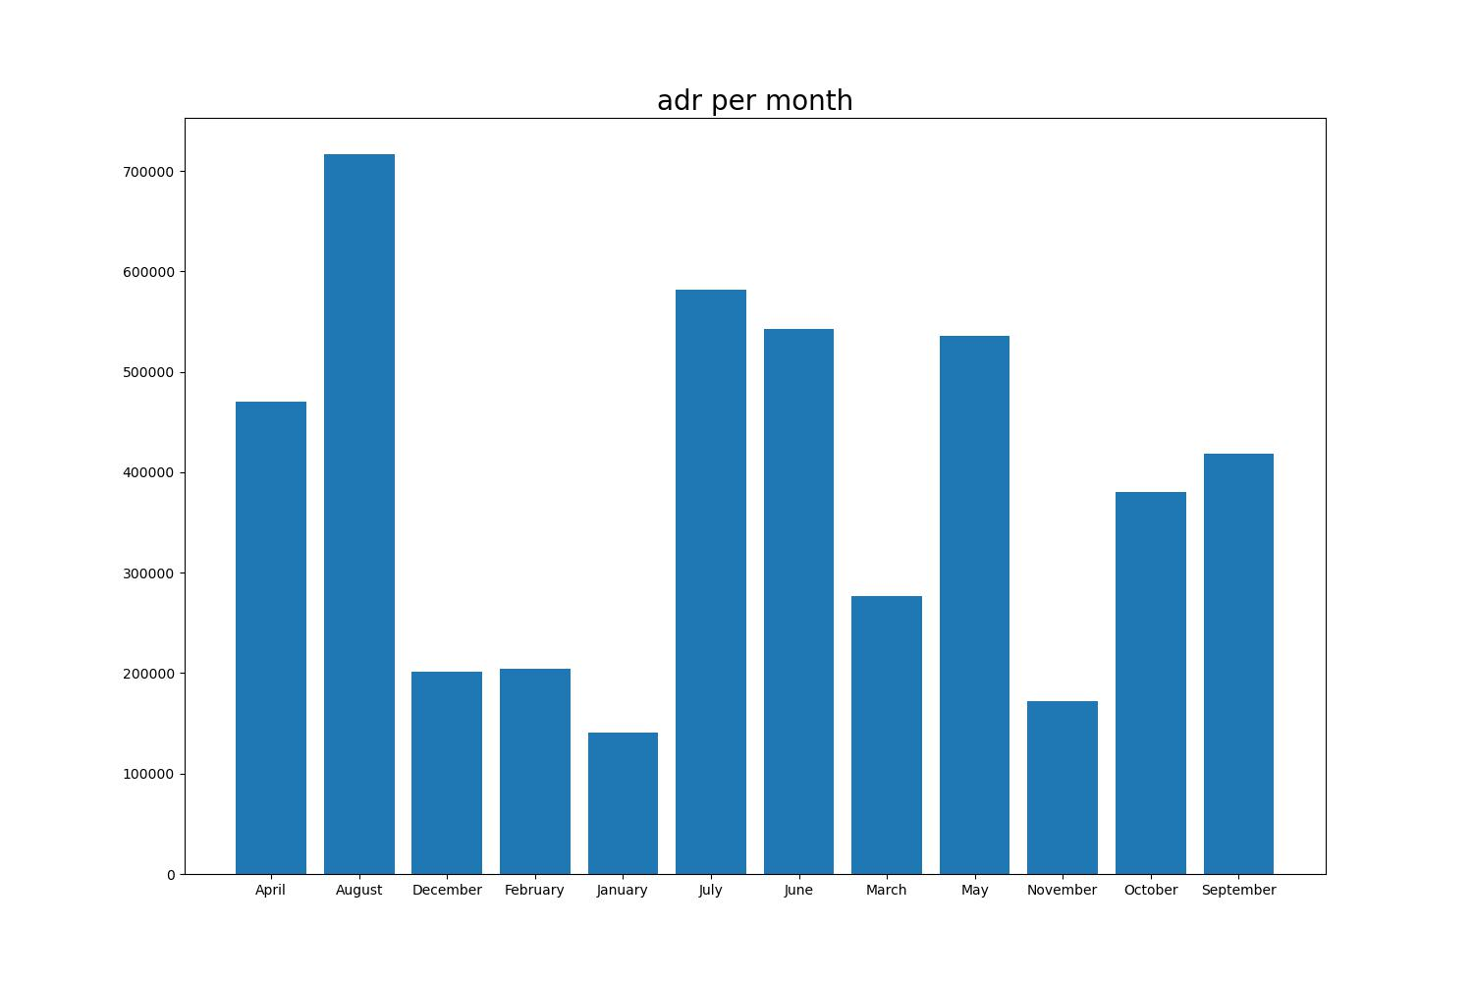

This bar graph demonstrates that cancellation is common when prices are greatest and least common when prices are lowest. Thus the cost of accommodation is solely responsible for cancellation.

Portugal has highest reservation cancelled.

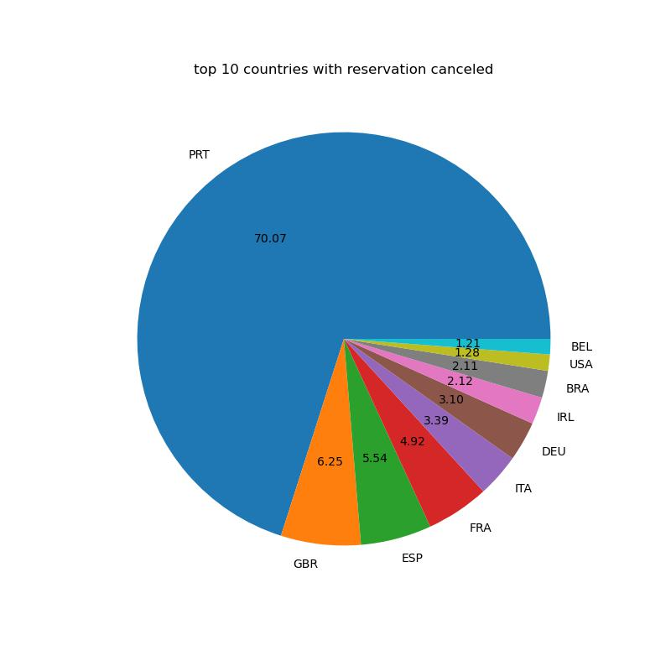

Lets check the area from where guest are visiting hotels and making reservations.46% of the client come from online and 27% of client come from groups and only 4% come directly hotels and making reservation.

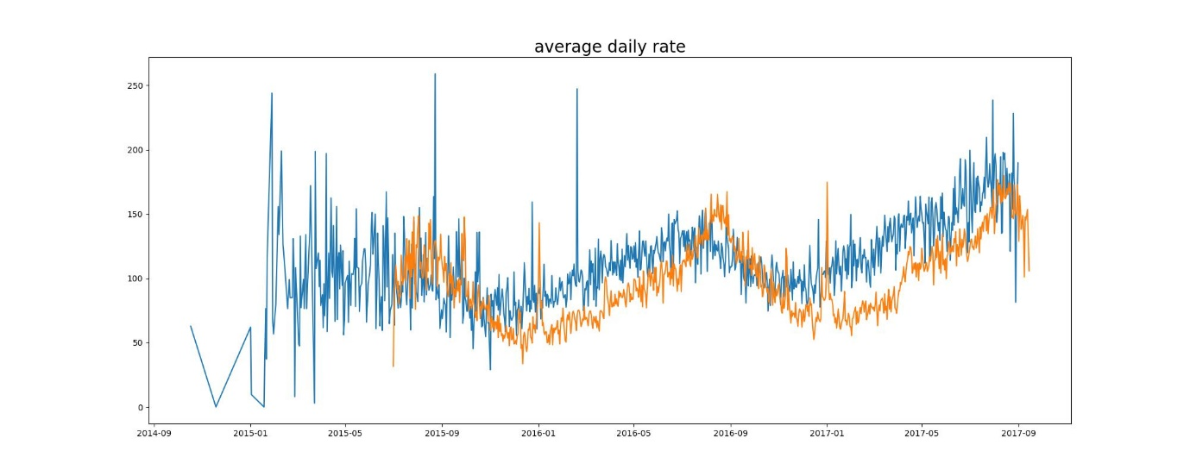

As seen in the graph reservation is cancelled when the ADR is higher than when it is not cancelled. That proves higher price leads higher cancellation.

**SUGGESTIONS**

* Cancellation rates rises as price does. In order to prevent cancellation of reservation the hotel could work on price strategies and try to lower the rate of specific hotel based on locations. They can also provide some discounts to customers.
* As the ratio of cancellations and not cancellation of resort hotels is higher than the city hotels. So the hotels should provide reasonable discount on the room prices on the weekends and on holidays.
* they can also increase the quality and services of hotel specially in Portugal to reduce cancellation rate.